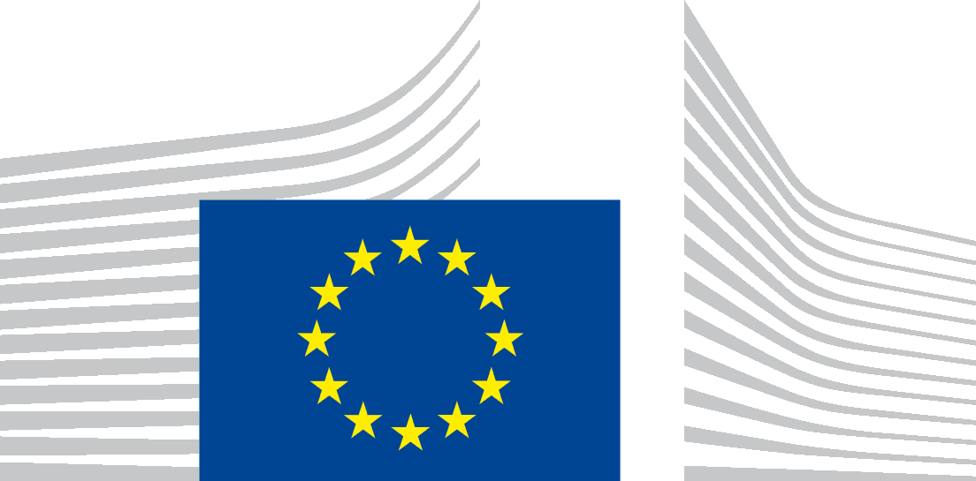 | EUROPEAN COMMISSION  DIRECTORATE-GENERAL FOR EDUCATION, YOUTH, SPORT AND CULTURE  Youth, Education and Erasmus+  Schools and Multiligualism
Paper form requesting consent
Regulation (EU) 2018/1725 obliges the EU Institutions to guarantee an equivalent level of protection as the EU General Data Protection Regulation (EU) 2016/679 when they are processing personal data.
Unit EAC.B.2 of Directorate – General for Education, Youth, Culture and Sports of the European Commission is handling my personal data for the purposes of implementation of the European Innovative Teaching Award in accordance with the principles of Regulation (EU) 2018/1725, and as detailed in the attached privacy statement, also available on https://innovative-teaching-award.ec.europa.eu/.
In line with the provisions of this Regulation, I hereby express my explicit consent as parent/legal representative of the minor named [full name of Minor in capital letters] and aged [age of Minor in numbers] to process their personal data for one or more of the following ticked purposes:
☐ Direct communication with the legal representatives, project coordinators, project participants of the awarded projects related to participation in Award ceremonies and networking events (including travelling and accommodation aspects);
☐ Promotion of the awarded projects through publications of photos and videos in a dedicated website, Erasmus+ website and social media channels, Erasmus+ publications, etc. (including showing faces in recognisable manner).
The unticked boxes mean my dissent for processing the personal data of the minor for the corresponding purposes.
I understand that I can freely withdraw my consent at any time. In that case, all processing operations that were based on my consent and took place before the withdrawal of consent remain valid.
The personal details contained in the present consent form will be kept by the European Commission as proof of my consent.
To exercise my rights under Regulation (EU) 2018/1725, I can contact the European Commission at the following address: EAC-UNITE-B2@ec.europa.eu
I have read and understood the privacy statement and the conditions of this consent form.
Please write down the mention “read and approved” (handwriting):
First name, surname:
Location, Date:Signature:

